recommend the following structure for your report:

Abstract:

A short overview of your paper.

Introduction:

What is the problem setting of the project (and why is this a problem at all)? What is

your concrete (research) question you want to solve? What is your overall idea for solving it (briefly).

What comes in the remainder of the paper?

Background and/or Related Work:

This section contains the required background knowledge for

reading the report. For instance, if you use a specific type of feature selection or a (not so standard)

visualization it should be explained here. A related work part is necessary if other authors have done

the same (maybe solved the same problem on the same data set with a different approach). Depending

on your topic, the section could either be ”Background” (very practical topic), ”Background and Re-

lated Work” (practical topic with additional scientific references) or ”Related Work” (very scientific

topic). Depending on the topic, the section can also be split into ”Background” and ”Related Work”.

Approach:

Here you describe how you solved the problem. A good ”approach” section is not a

historical review on what you’ve tried step by step (and where you failed) – so it is not an experience

report. But rather you describe the approach that finally worked. Things that failed (and why) go into

the discussion section. If you tried multiple paths and all of them are reasonable and lead to different

results (with advantages and disadvantages), those should be described (and discussed later). This

section might of course contain subsections.

Experiments:

This section (empirically) proves what your approach claims. The experiment section

contains all the information necessary to judge to which extend the problem you stated in the intro-

duction is solved by the steps you proposed in the approach section. Usual subsections contain a data

set description, the general experimental setup and the results.

Discussion:

Here you interpret the results you achieved in the experiments, and discuss it in relation

to other works (if applicable). It should also contain the limitations (what did not work and an

hypothesis why) and observations you made during the experiment.

Summary: or Conclusions

This section summarizes the work. In a way it is a different view on the

things you wrote in the introduction. Which problem was attacked, was it solved? What would be

next steps and/or application areas. Do not repeat the details, but summarize the work

**KPI’s for Saxion and Utwente**

Does the data comply with own KPI’s? (this is step 1)

Both - Relate Datasets to each other

Student - Mike

Teacher / Rooms - Ernst

|  |  |  |
| --- | --- | --- |
| KPI (subject) | Measured by data attribute | Organization |
| Timetabling hours (student) |  | Saxion |
| Teaching hours (student) |  | Saxion |
| Pauses (student) |  | Saxion |
| Location & Building (student) |  | Saxion |
| Timetabling hours (teacher)  Start 8:30 End 18.00  Max 10 hours and average 8  Part-time education after 20.30 = next morning free | Teacher,Start , End | Saxion |
| Teaching hours (teacher)  Max 8 hours of which 6 for lecturers | Teacher,start,end | Saxion |
| Pauses (teacher)  After max 6 series lectures 1 free hour  Teaching part-time min 45 min free between 16.30-18.30 | Teacher,start,end | Saxion |
| Location & Building (teacher)  Max 1 time travel to other location and max 2-time travel to other building within the same location | Teacher, place, room | Saxion |
| Students min 4 contact hours |  | UT |
| Students max 6 contact hours on any day |  | UT |
| Students have max 2 free hours in 1 series on any day |  | UT |
| Students have max 8:15 clock hours lecture (11 college hours) on any given day. |  | UT |
| If a student has class at 11 and 12th hour then no class at 1st and 2nd hour the next day |  | UT |
| At Friday there are no evening classes |  | UT |
| A teacher has max 8 contact hours per day | Teacher, course code, time start, end, date | UT |
| If a teacher has class at 11 and 12th hour then no class at 1st and 2nd hour the next day | Teacher, course code, time start, end, date | UT |
| Rooms must have an occupation of at least 70%. Defined by occupying space by the timetabling process during educational weeks | Course code, activity room | UT |

**UT data model**

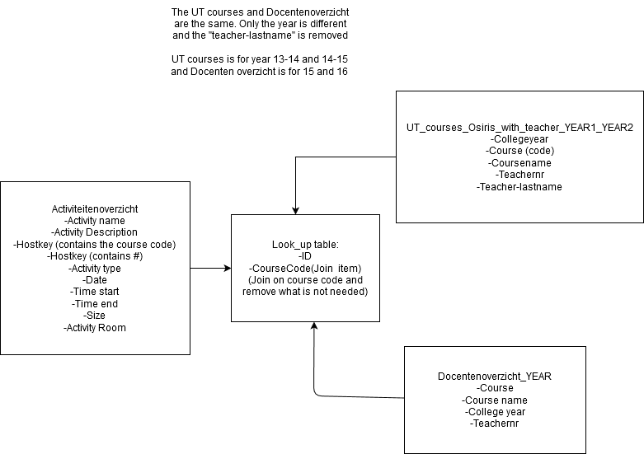

There are 3 kinds of Excel sheets, which 2 serve the same purpose. So I propose a look_up table with an ID and the course code. With this course code, you can find all the information on the other sheets.

**Saxion data model:**

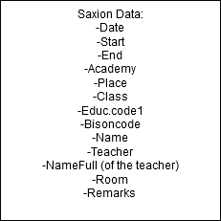

There is only 1 Excel sheet, so there isn’t really a model.

**Visualization (search for patterns)**

What are we going to visualize (this is step 2 and step 3)

Exploration - Ernst

Trend Analysis - Mike